भारतमौसमविज्ञानविभाग |  | India Meteorological Department
Tuesday, 24th June 2025 (3rd Ashadha 1947 Saka)
Summary of observations recorded at 0830 hours IST: Southwest monsoon has further advanced over remaining parts of north Arabian Sea, some more parts of west Uttar Pradesh, some parts of Haryana; Chandigarh, remaining parts of Himachal Pradesh & Jammu and some more parts of Punjab. The Northern Limit of Monsoon now passes through 25.0°N/60.0°E, 25.0°N/65.0°E, 25.5°N/70.0°E, Barmer, Jodhpur, Jaipur, Agra, Rampur, Bijnor, Karnal, Halwara and 33.0°N/70.5°E. Conditions are favourable for further advance of Southwest monsoon over some more parts of Rajasthan, Punjab, Haryana, entire Delhi and remaining parts of West Uttar Pradesh during next 36 hours. The upper air cyclonic circulation over central parts of south Uttar Pradesh extending upto 5.8 km above m. s. l tilting southwards with height persisted. The trough from the cyclonic circulation over central parts of south Uttar Pradesh to northwest Bay of Bengal across northeast Madhya Pradesh, Jharkhand & north Odisha extending upto 1.5 km above m. s. l. persisted. A trough ran from Punjab to north Bangladesh across the cyclonic circulation over central parts of south Uttar Pradesh at 0.9 km above m. s. l. An upper air cyclonic circulation lay over south Jharkhand & neighbourhood between 3.1 and 7.6 km above m. s. l. tilting southwards with height. A trough ran from northeast Arabian Sea to the above cyclonic circulation over south Jharkhand & neighbourhood at 3.1 km above m. s. l. The upper air cyclonic circulation over northeast Assam & neighbourhood lay over central Assam & neighbourhood at 0.9 km above m. s. l. The upper air cyclonic circulation over westcentral and adjoining northwest Bay of Bengal off north coastal Andhra Pradesh & south Odisha coast merged with above cyclonic circulation The upper air cyclonic circulation over Saurashtra & Kutch became less marked. The trough roughly along Long. 87°E to the north of Lat. 21°N became less marked.
Day temperatures were markedly above normal (> 5.1°C) at few places over Jammu-Kashmir-Ladakh-Gilgit-Baltistan-Muzaffarabad; at isolated places over Himachal Pradesh and Chhattisgarh. appreciably above normal (3.1°C to 5.0°C) at isolated places over Gangetic West Bengal; above normal (1.6°C to 3.0°C) at isolated places over Assam & Meghalaya, Sub Himalayan West Bengal & Sikkim, Odisha and Konkan & Goa; near normal (-1.5°C to 1.5°C) at many places over Nagaland, Manipur, Mizoram & Tripura, Jharkhand and Kerala & Mahe; at most places over coastal Karnataka and Lakshadweep; at few places over Andaman & Nicobar Islands, Arunachal Pradesh, Bihar, Uttarakhand, Punjab, West Rajasthan, Saurashtra & Kutch, Madhya Maharashtra, Marathwada, Telangana, Tamil Nadu, Puducherry & Karaikal and south interior Karnataka; at isolated places over east Uttar Pradesh, west Uttar Pradesh, Haryana-Chandigarh-Delhi and north interior Karnataka. The highest maximum temperature of 42.6°C was reported at Sriganganagar (Rajasthan).
The Southwest Monsoon has been vigorous over Gujrat Region and active over Sub-Himalayan West Bengal & Sikkim, Jharkhand, east Madhya Pradesh, Konkan & Goa. It has been subdued over Marathwada and Rayalaseema.
Total 324 stations reported rainfall today. Total rainfall is 339.4 cm. Total 313 stations reported rainfall today whose normals are available. Total rainfall is 327.6 cm with normal station total is 258.5 cm.
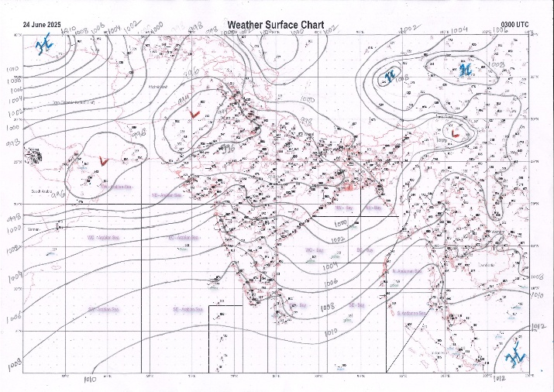 | 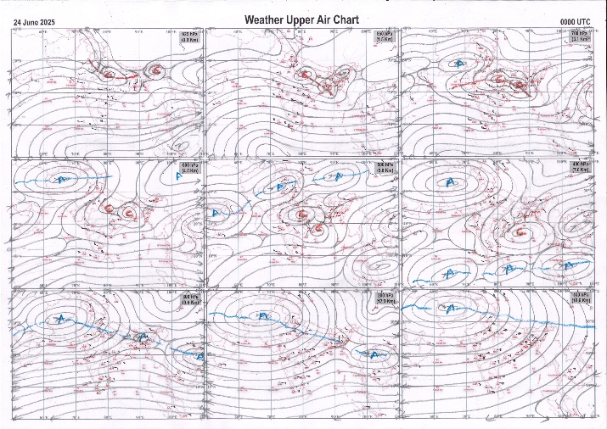
g.1. Analysed surface chart based on 03z observation | Fig.2. Analysed upper air chart based on 00z observation

Dr. S D Sanap.
Scientist ‘D’
CR & S Office, Pune  Issued at 1245 hrs. IST |  | Weather Forecasting Division  CR&S, Pune

Indian regions | Realised rainfall (chief amount in cm during past 24 hrs):
East | most places: Arunachal Pradesh+++ and Sub-Himalayan West Bengal & Sikkim#  many places: Assam & Meghalaya+++, Nagaland-Manipur-Mizoram-Tripura+, Odisha+ and Jharkhand  a few places: Gangetic West Bengal and Bihar+++  Kumargram 27.7, Gajoldoba 24.7, Gossaigaon & Gossaigaon AWS 17.5 each, Galgalia 12.0, Bhalukpong 11.9, Cooch behar 11.4, Tiring 9.7, Areraj 8.7, Majbat 8.3, Tuting 7.6, Kashipur 6.9, Lamseng ARG 6.5, Jamshedpur & Padma dvc 6.0 each, Hazaribagh kvk AWS 5.5, Manteswar 4.7, Bolangir & Forbesganj 4.5 each, Mangkolemba 4.4, Pasighat AP & Diamond harbour 3.6 each, Labpur 3.2, Imphal AP 2.4.
North | many places: Uttarakhand+++  a few places: west Uttar Pradesh, Haryana+++, Punjab+++, Himachal Pradesh and east Rajasthan+++  isolated places: east Uttar Pradesh, Jammu-Kashmir and Ladakh and west Rajasthan  Mangrol 18.0, Shahabad 16.6, Lohand 12.0, Sama 11.8, Shahbad 11.6, Babain REV 10.5, Haripur 10.0, Khanna 9.8, Ludhiana 7.2, Nadaun 6.3, Hamirpur 6.1, Rath 6.0, Nainital 5.9, Bareilly CWC 5.4, Bareilly PBO & Sardarshahar 4.9 each, Pungal SR 4.7, Rihand dam fmo & Jaipur AP 4.6 each, Rajouri ARG 4.5, Mandi 3.4, Kannauj (t) & Narnaul 3.3 each, Reasi ARG 3.1, Katra 2.6, Gorakhpur 1.9, Bikaner (pbo) 0.3.
Central | many places: west Madhya Pradesh+++, east Madhya Pradesh+, Vidarbha+ and Chhattisgarh+  Karhal 12.3, Kolaras 11.5, Sheopur-aws 9.4, Bilaspur 8.3, Kumdam 8.2, Chindwara-aws 7.7, Samari 7.2, Bhamragad 7.1, Chando 6.9, Ahiri 5.6, Champa 3.5, Bramhapuri 1.5.
Peninsula | most places: Konkan & Goa# and coastal Karnataka+++  many places: Gujarat Region#, Saurashtra & Kutch, Madhya Maharashtra+++ and Kerala  a few places: coastal Andhra Pradesh and interior Karnataka+  isolated places: Marathwada, Telangana+, Rayalaseema and Tamil Nadu  Kamrej 27.5, Bardoli 25.9, Jawhar 23.1, Vikramgad 19.7, Lonavala ARG 17.8, Matheran 16.5, Mahabaleshwar 15.9, Radhanagari 13.9, Siddapura 12.7, Surat city 11.7, Castle rock 10.1, Khanapur 9.6, Agumbe emo 9.5, Londa 7.6, Somwarpet 7.5, Dahegaon 6.9, Kottigehara 6.7, Irikkur 6.3, Bejjur 6.1, Wankaner 5.3, Barvala 5.2, Nilambur 4.5, Karwar 4.0, Avalanche 3.7, Belagavi PTO & Palakkad 3.3 each, Chinnakalar 3.1, Ichchapuram 3.0, Mahuva (b) 2.5, Mentada 2.1, Valparai PTO 1.7, Kalingapatnam & Banaganapalle 1.5 each, Dornipadu 1.4, Mahur 0.9, Himayatnagar 0.8, Nalgonda 0.6, Sambhajinagarobsy 0.2.
Islands | most places: Andaman & Nicobar  a few places: Lakshadweep  Port blair & Long island 5.3 each, Maya bandar 4.2, Minicoy 0.6, Amini 0.1.
Table 2. Forecast / warnings (distribution of rain / thundershowers) for 7 days (valid from time of origin upto 0830 hrs IST of next day)
Sr N. |  | Sub-division Name | Day 1 | Day 2 | Day 3 | Day 4 | Day 5 | Day 6 | Day 7 | Sr. No. | Sub-division Name | Day 1 | Day 2 | Day 3 | Day 4 | Day 5 | Day 6 | Day 7
 |  |  | 24 Jun | 25 Jun | 26 Jun | 27 Jun | 28 Jun | 29 Jun | 30 Jun |  |  | 24 Jun | 25 Jun | 26 Jun | 27 Jun | 28 Jun | 29 Jun | 30 Jun
 | 1 | Andaman Nicobar Islands | W  | F  | F  | F | W | W | F | 19 | west Madhya Pradesh | W ++  | W +  | W + | W +  | F +  | F + | F +
 | 2 | Arunachal Pradesh | W ++  | F +  | F +  | F ++  | W ++  | W ++ | W ++ | 20 | east Madhya Pradesh | W ++  | W +  | W +  | W +  | W +  | F + | F +
 | 3 | Assam-Meghalaya | W ++  | F +  | F +  | F +  | F +  | F + | F + | 21 | Gujarat region | W # | W ++  | W ++ | W ++  | W ++  | W ++ | W ++
 | 4 | Nagaland-Manipur-Mizoram-Tripura | F ++  | F +  | F +  | F ++  | F ++  | F + | F + | 22 | Saurashtra and Kutch | W ++  | W + | W +  | W +  | W +  | W + | W +
 | 5 | Sub Himalayan West Bengal/Sikkim | W ++ | F + | F | W | W + | W + | W | 23 | Konkan and Goa | W # | W ++  | W ++  | W ++  | W ++  | W ++ | W ++
 | 6 | Gangetic West Bengal | F  | W +  | W +  | W + | W | F | F | 24 | Madhya Maharashtra | S # | S ++  | S++ | S ++ | S ++ | S ++ | S ++
 | 7 | Odisha | W +  | W++  | W ++  | F +  | F + | S | S | 25 | Marathwada | I  | I  | I  | I | I | I | I
 | 8 | Jharkhand | W +  | W +  | W ++  | W +  | F | F | F | 26 | Vidarbha | W +  | W +  | F  | F  | S  | S | S
 | 9 | Bihar | F +  | S +  | S +  | S +  | F ++  | F  | F  | 27 | Chhattisgarh | W +  | W +  | W +  | W +  | W +  | F | F
 | 10 | east Uttar Pradesh | S  | F  | F  | W +  | W +  | W +  | W +  | 28 | Coastal Andhra Pradesh and Yanam | F  | S  | S  | F +  | F  | S | S
 | 11 | west Uttar Pradesh | S +  | F ++  | W +  | W ++  | W +  | W +  | W +  | 29 | Telangana | S  | I  | I  | I  | I  | I | I
 | 12 | Uttarakhand | F ++  | W ++  | W ++  | W++  | F +  | W +  | W+  | 30 | Rayalaseema | I | I | I | I | I | I | I
 | 13 | Haryana,Chandigarh and Delhi | S  | F ++  | W ++  | F +  | F +  | F +  | F +  | 31 | Tamil Nadu, Puducherry and Karaikal | I | I  | S  | S +  | S +  | I | I
 | 14 | Punjab | S  | F ++  | W ++  | F +  | F  | F +  | F +  | 32 | Coastal Karnataka | W ++  | W++  | W++ | W + | W + | W | W
 | 15 | Himachal Pradesh | F + | W ++  | W ++  | W +  | F | F + | F + | 33 | North interior Karnataka | S ++  | S +  | S +  | F +  | S  | S | S
 | 16 | Jammu-Kashmir and Ladakh | S  + | W ++  | W +  | W +  | S  | S  | S  | 34 | South interior Karnataka | F ++  | F +  | F +  | W +  | F +  | S | S
 | 17 | west Rajasthan | S +  | I  | S +  | F ++  | F ++  | F +  | S | 35 | Kerala and Mahe | W +  | W +  | W +  | W + | W + | F | F
 | 18 | east Rajasthan | F ++  | F +  | F +  | F++  | F +  | F +  | S | 36 | Lakshadweep | F  | W  | W  | W | W | F | F
Legends: D = Dry I = Isolated S = Scattered F = Fairly widespread W = Widespread #= heavy to very heavy rain at a few places with extremely heavy rain at isolated places +++= heavy rain at a few places with very heavy rain at Isolated places ++= heavy to very heavy rainfall @=Isolated exceptionally heavy rainfall + = heavy rain ●/*= rain or snow ♦ = very light rain ≡=fog= thunderstorm with lightning =Squall / Gusty / gale / strong wind ­ =cold wave/cold day += heat wave/warm night/hot and humid weathe r=Duststorm =ground frost = Hail

Fig. 4: Districtwise warnings for five days for Maharashtra State
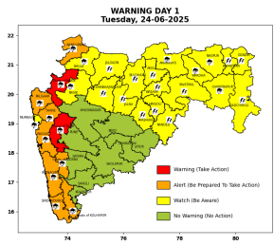 | 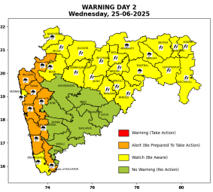 | 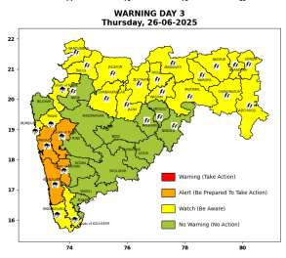 | 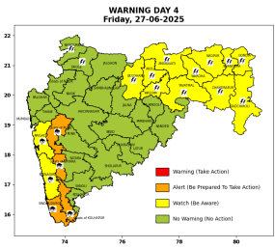 | 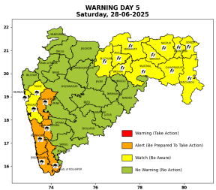

Pune, Lohegaon and Pashan observations at 0830 hrs. IST of Today
 | Temperature (°C) |  |  |  |  | Humidity (%) |  |  |  | Rainfall (mm)
 | Max.  past  24 hrs | Dep.  from  normal | Min.  past  24 hrs. | Dep.  from  normal | Dry  Bulb | At 0830 hrs. IST | Dep.  From  normal | At 1730  hrs. IST of y’day | Dep.  from  normal | Past  24 hrs. | Since  1st June | Dep.  from  normal
PNE | 28.9 | -1.5 | 20.8 | -2.2 | 22.6 | 91 | 13.0 | 72 | 2.0 | 18.1 | 259.8 | 140.7
PSN | 27.6 | - | 19.9 | - | 22.0 | 100 | - | 80 | - | 21.6 | 291.9 | -
LHG | 30.6 | -0.4 | 22.2 | 1.2 | 23.6 | 89 | 11.0 | 63 | -2.0 | 9.0 | 241.8 | 167.0

 |  |  |  |  |  |  | Local (Pune and neighbourhood) forecast
Max./Min. Temperature (°C) |  |  |  |  |  |  |  |  | Weather
Date | Pune | Pashan | Lohegaon | Chinchwad | Lavale | Magarpatta | NDA | Koregoan Park
24/06/25 | 30 / 20.8* | 30 / 19.9* | 32 / 22.2* | 29 / 20.3* | 28 / 20.4* | 30 / 22.0* | 28 / 20.9* | 30 / 22.2* | Generally cloudy sky. Light to moderate rain very likely.(Heavy to very heavy rainfall at a few places with extremely heavy rainfall at isolated places)
25/06/25 | 30 / 21 | 28 / 20 | 32 / 22 | 28 / 20 | 28 / 22 | 30 / 22 | 28 / 21 | 29 / 22 | Generally cloudy sky. Light to moderate rain very likely.
26/06/25 | 31 / 21 | 29 / 20 | 33 / 22 | 29 / 20 | 29 / 22 | 31 / 22 | 29 / 21 | 30 / 22 | Generally cloudy sky. Light rain very likely.
27/06/25 | 31 / 22 | 29 / 21 | 33 / 23 | 29 / 21 | 29 / 21 | 31 / 23 | 29 / 22 | 30 / 23 | Generally cloudy sky. Light rain very likely.
28/06/25 | 30 / 22 | 28 / 21 | 32 / 23 | 28 / 21 | 28 / 21 | 30 / 23 | 28 / 22 | 29 / 23 | Generally cloudy sky. Light to moderate rain very likely.
29/06/25 | 29 / 21 | 27 / 20 | 31 / 22 | 27 / 20 | 27 / 21 | 29 / 22 | 27 / 21 | 28 / 22 | Generally cloudy sky. Light to moderate rain very likely.
30/06/25 | 29 / 21 | 27 / 20 | 31 / 22 | 27 / 20 | 27 / 21 | 29 / 22 | 27 / 21 | 28 / 22 | Generally cloudy sky. Light to moderate rain very likely.
Rainfall Distribution |  |  | Rainfall Categories | Rainfall (mm) |  | Cloud condition |  |  |  | Rainfall Intensity |  | Range
Widespread (W) | 76-100% |  | Very Light rain | Trace to 2.4 mm |  | Mainly clear sky |  | 1-2 oktas |  | Light Spell |  | 1 cm/hr
 |  |  | Light rain | 2.5 to 15.5 mm |  | Partly cloudy sky |  | 3-4 oktas |  | Moderate Spell |  | 1-2 cm/hr
Fairly Widespread (FW) | 51 – 75% |  | Moderate rain | 15.6 to 64.4 mm |  | Generally cloudy sky |  | 5-7 oktas |  | Intense Spell |  | 2-3 cm/hr
Scattered (S) | 26 – 50% |  | Heavy rain | 64.5 to 115.5 mm |  | Overcast |  | 8 oktas |  | Very Intense Spell |  | 3-5 cm/hr
isolated (I) | 1 – 25% |  | Very heavy rain | 115.6 to 204.4 mm |  |  |  |  |  | Extremely Intense Spell |  | 5-10 cm/hr
D (D) | No Rain |  | Extremely heavy rain | ≥ 204.5 mm |  |  |  |  |  | Cloudburst |  | > 10 cm/hr
Probability Terms in %: |  |  | Heavy snow | 6.5 to 11.5 cms water equivalent of rain
unlikely | < 25 |  | Very heavy snow | 11.6 to 20.4 cms water equivalent of rain
likely | between 25 50
very likely | between 51 75
most likely | >75
* = realized temperature
Mumbai (Colaba) |  |  |  | Nagpur (AP)
Date 2025 | T max °C | T min °C | Weather | T max °C | T min °C | Weather
24/06 | 31 | 25 | Generally cloudy sky with heavy rainfall. | 32 | 25 | Generally cloudy sky with Heavy rain or thundershowers accompanied with Lightning.
25/06 | 31 | 25 | Generally cloudy sky with heavy rainfall | 30 | 24 | Generally cloudy sky with a few spells of rain or thundershowers or thundershowers accompanied with Lightning.
26/06 | 30 | 23 | Generally cloudy sky with heavy rainfall | 30 | 24 | Generally cloudy sky with a few spells of rain or thundershowers or thundershowers accompanied with Lightning.
27/06 | 29 | 23 | Generally cloudy sky with moderate rain. | 29 | 25 | Generally cloudy sky with a few spells of rain or thundershowers or thundershowers accompanied with Lightning.
28/06 | 30 | 25 | Generally cloudy sky with heavy rainfall | 30 | 25 | Generally cloudy sky with a few spells of rain or thundershowers or thundershowers accompanied with Lightning.
29/06 | 31 | 25 | Rain. | 30 | 24 | Generally cloudy sky with possibility of rain or thunderstorm
30/06 | 31 | 25 | Rain. | 30 | 24 | Generally cloudy sky with possibility of rain or thunderstorm

